1. **Which of the following best describes your age?**
   * + **Under 18**
     + **18-24**
     + **25-40**
     + **Above 40**

#### What gender do you most identify with?

* + - **Female**
    - **Male**
    - **Other**

**3.  Are you a registered to vote?**

* + - **yes**
    - **no**
    - **Unsure/Don’t Know**

#### 4. In the last 5 years did you vote in a local election? This includes voting for Councillor or mayors

* + - **yes**
    - **no**

**5.  Are you planning on voting in the upcoming 2021 elections?**

* + - **yes**
    - **no**
    - **Maybe**

#### 6. Do you feel that you fully understand the election process?

* + - **A great deal**
    - **A little**
    - **A lot**
    - **None at all**
    - **A moderate amount**

#### 7.  Which of the following best describes your decision to vote in the 2021 election?

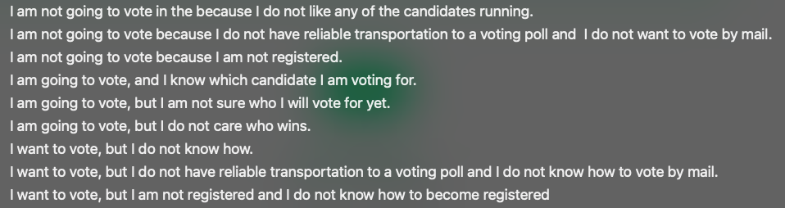

**Are you registered to vote at the current address you reside at?**

* **Yes**
* **No**

**Do you think the existing government is going in the right direction to benefit the people of the country?**

* **Yes**
* **No**

Which party do you support to handle sensitive topics such as national security?

* + Democrats
  + Republicans
  + Don’t know
  + I don’t support any party

**On what basis do you assess a political candidate?**

* **News on TV**
* **Articles in the newspapers**
* **Attend events where the candidate is addressing the people**
* **I research all the channels before making my choice**
* **Number of fundraisers the candidate has done in your area**
* **The family upbringing of the candidate**
* **Other**

Do you think there should be stricter rules and regulations on the use of money in political campaigns?

* Yes
* No
* Don’t know

On the day of voting will you vote for the same party which you voted now or your decision may change?

1. Vote for the same party

2. May change

3. Not prefer to say

In this election, have you participated in the following activities?

Activities (Yes or No)

a. Contributed or collected money?

b. Attended election meetings/rallies?

c. Participated in door to door canvassing?

d. Distributed election leaflets or put up posters?

What is your assessment of the performance of the AIADMK government in Tamil Nadu in the last five years? Would you say that you have been satisfied or dissatisfied with it?

1. Fully satisfied

2. Somewhat satisfied

3. Somewhat dissatisfied

4. Fully dissatisfied

5. No response

How would you rate EPS’s performance as the Chief Minister of Tamil Nadu – has it been very good, good, bad or very bad?

1. Very good

2. Good

3. Bad

4. Very bad

5. No response

During the last two- three years have you or any of your family members benefited from any Government scheme ?

1. Yes

2. No

3. No response

How would you rate EPS as a leader of Tamil Nadu? Would you say she is very corrupt, somewhat corrupt, honest, or very honest?

1. Very corrupt

2. Somewhat corrupt

3. Honest

4. Very honest

5. No response

AIADMK / BJP

DMK / CONGRESS

MNM

PWF/DMDK/Left

PMK

NOTA